---------Staff----------
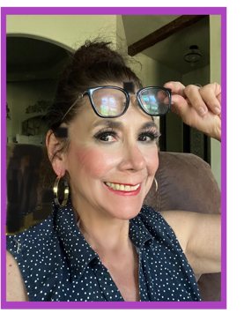Silvia Gonzalez Scherer is the volunteer Artistic Director and co-founder of the Hanford Multicultural Theater Company, officially launched on February 1, 2017, alongside her daughter, Camia A. Scherer. Her journey in the arts began with ventriloquism, which sparked a passion for stand-up comedy and eventually led her to acting, including work in improvisation.
Silvia’s love for storytelling evolved into playwriting, earning her awards, productions, and publications. Today, she channels her talents into teaching and mentoring diverse actors by combining her expertise in acting, improv, puppetry, poetry, and playwriting. Her nurturing approach, paired with her broad artistic experience, makes her an invaluable mentor to emerging artists.
During the pandemic, Silvia expanded her skill set to include filming and editing, further enhancing her ability to create and share dynamic theatrical content.
 Camia Scherer is a volunteer managing director and also co-founder of Hanford Multicultural Theater Company. Her astute skills in the digital world has propelled the theater forward. Camia is a dedicated professional with a BA in Psychology and a passion for making a difference. She has worked with DSP for troubled teens and as an ABA therapist for children on the spectrum. Beyond her professional work, she is a creative soul, running a photography business that captures life’s special moments. When she is not behind the camera, she is spends time with her two beloved cats. Whether through helping others or creating art, Camia is always looking to bring a little more light into the world.
 Julio C. Gonzalez, Jr., Volunteer Outreach coordinator and PR. Julio serves the city as a regional planner. A regional planner helps guide how land is used and how communities grow—not just within one city, but across a broader area. Their goal is to balance development, transportation, housing, environment, and economic needs in a coordinated way. As his office is one block away, uses his lunch hour to come to the theater and work on outreach. He was also instrumental in creating a platform for poets, storytellers, and stand-up comedians by engineering the Whatever open mic, held monthly at the theater. He also brought musicians into the mix. Last open mic we had a rap artist and a breakdancer grace our stage. An idea man, he is also instrumental in fundraising. When not busy, Julio is also a little league soccer commentator.
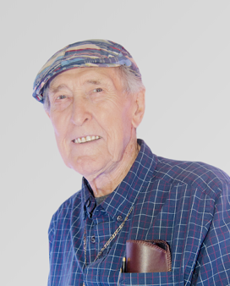 Don Brakeman is a professional actor, director, and dedicated volunteer acting teacher, currently inspiring students at the age of 93. He received his SAG card in 1969 and, after semi-retiring in 2008, returned to Las Vegas in 2012 to work on the film Lake Mead Drowned, produced and directed by Jessica Chandler and Eli Roth of Camp Grey Productions. That year, he also performed in three Shakespearean productions, portraying roles in Macbeth, Claudius in Hamlet, and King Lear.
Mr. Brakeman’s film credits include Amygdala Warrior, Buckaroo: The Movie, and Dr. Ice. His television appearances feature The Rockford Files, America’s Most Wanted, and other notable programs. He was also featured in the independent film Top of the Morn’n Ta Ya and interviewed for the documentaries Brick by Brick and Retired and Inspired.
Locally, he received a Lizzie Award for Outstanding Achievement in Performance for his role as Candy in John Steinbeck’s Of Mice and Men. With a rich background in stage and live theater — including extensive Shakespearean work — Mr. Brakeman continues to teach and perform in community theater, contributing to organizations such as the Hanford Multicultural Theater Company, and previously engaging audiences in Las Vegas and Los Angeles.
 Mark Richard Saltzman is our volunteer puppet master. He has made puppets for us and taught puppetry classes. He has been performing since before it was cool — and he has the touring credits to prove it. A professional actor, dancer, and choreographer since 1990, he’s taken the stage across the US, Canada, Mexico, and Puerto Rico in productions like Guys & Dolls, The Sound of Music, and Joseph & the Amazing Technicolor Dreamcoat.
A fateful stint with Disney’s Bear in the Big Blue House and Sesame Street LIVE introduced him to the world of puppetry — and it stuck. Since 2000, Mark has been designing, building, and performing with custom puppets. He’s an alumnus of the prestigious US National Puppetry Conference at the Eugene O’Neill Theatre Center, and he brings all of it together through his company, Kiwuppet Studios.

 Ted Hillman is our hard-working Technical Engineer volunteer for Hanford Multicultural Theatre Company, who stepped in during a critical time after the unexpected loss of our long-time technical engineer in November. He quickly mastered the theater’s systems, helping the company continue its productions without interruption.
A skilled live music professional, Ted has worked as a backline engineer for touring artists, including Sublime with Rome and Pepper, bringing technical expertise and a deep understanding of live performance production. A Hanford native, he is committed to strengthening his local arts community. At the Lil Brick Theatre, Ted works to expand performance opportunities for local musicians and foster collaboration among artists throughout the San Joaquin Valley, supporting both artistic growth and community engagement in the region. Ted is honoring his Latina mother by writing a story about Tiburcio Vasquez.

. 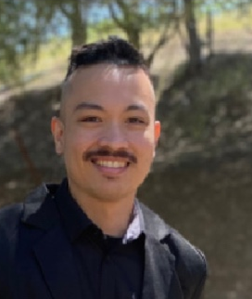 Stanley Abad Williams is our volunteer videographer and documentarian. He is a Filipino American filmmaker specializing in writing and directing. Raised in Hanford, California, he discovered his passion for storytelling at the age of 11—a passion that continues to shape and drive his creative work today.
His recent projects include Brick by Brick, a short documentary highlighting the Hanford Multicultural Theater Company. In addition to filmmaking, Stanley has expanded his creative portfolio through videography work with the Boys and Girls Club of Fresno County.
He is currently developing several projects, including the feature films The Séance and The Dead Walk!, as well as the short film My Cherry. His completed works include the feature films Pendant, Know Your Ways, and Dead Days, along with the short films Nova and Restricted.

-------Board Members------
 Silvia Gonzalez Scherer is a pistachio farmer with a side job as a payroll manager. Silvia is instrumental in making partnerships and locating donors to fulfill the mission of Hanford Multicultural Theater Company. A long-time advocate of the arts, Silvia shares her knowledge by teaching the youth acting, improv, performance poetry, and puppetry. Currently she has opened a branch of acting classes at the Santa Rosa Rancheria in Lemoore.
 Janie Isidoro is a published author and dedicated community advocate with more than 15 years of experience in grassroots organizing. She currently works with a nonprofit focused on multifamily housing initiatives for farmworkers, where she brings strategic insight, passion, and lived experience to advancing equity, housing stability, and opportunity for working families.
As a board member, Janie is committed to elevating community voices and fostering meaningful, sustainable impact through collaboration and advocacy. Her work reflects a deep dedication to social justice and strengthening underserved communities. She advocates and supports local and Latino artists/authors
Outside of her professional and advocacy work, Janie enjoys traveling and spending quality time with her family.
 Jasmine Posey Jasmine “Jas” Posey is a dynamic storyteller whose work brings compelling characters and narratives to life. Her performance credits include the 2022 Monologue Slam, The Mussel Slough Chronicles: A California Tragedy, The Trial of Bookus, Top of the Morn’n Ta Ya, as well as voice work for an exhibit at the Colorado Springs Discovery Center and multiple projects with Pdot Kids.
In addition to her artistic work, Jas serves as an interim board member for HMTC and is the founder of Pdot Literacy, an educational consulting company dedicated to promoting literacy and learning. She is a passionate advocate for equitable access to education, combining her creative talents with her commitment to community engagement.
Beyond her professional and advocacy work, Jas is a singer, content creator, and dedicated family member, embracing her roles as wife and mother while continuing to inspire others through storytelling, performance, and education.

